* **Expert, Discreet Installation** that retains the original factory appearance of your vehicle’s interior
* **Pinpoint Accuracy –** Features Front & Rear Radar Receivers that provide maximum protection as well as threat location. LNA (Low Noise Amplifier) radar receiver technology for greater range and performance
* **Integrated K40 Laser Defuser Protection** – Become invisible to police laser guns. Delivers bumper-to-bumper speeding ticket protection
* **Your safety is the first thing we engineer into our products:** K40 puts the control right at your fingertips, right where you want it!
* **Full customizable GPS technology** reduces false alerts and offers customizable notifications such as Auto-Filter, Mark to Mute, and Quiet Ride
* **Integration Ready:** The Platinum 360 can integrate with select radios to provide a visual and touch on-screen experience.
* **Not a one-size-fits-all!** We will help you determine the system set up that makes the most sense for your vehicle, budget and where you drive.
* **No programming or ongoing updating needed.** Quiet and easy to use right after the installation is complete
* **Ticket-Free Guarantee:** Drive with confidence with K40's 100% Ticket-Free Guarantee. In the unlikely event you should receive a speeding ticket in the first 12 months of ownership, K40 pays.
* **1 on 1 setup with K40’s dedicated representative** – to ensure you get the most out of your investment!

**Wireless Remote Control**

Check your system settings and make changes on the fly without taking your eyes off the road.

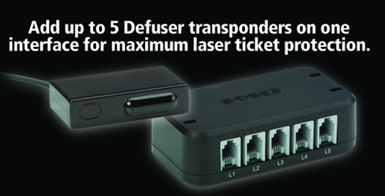

**Delivers bumper-to-bumper speeding ticket protection!**



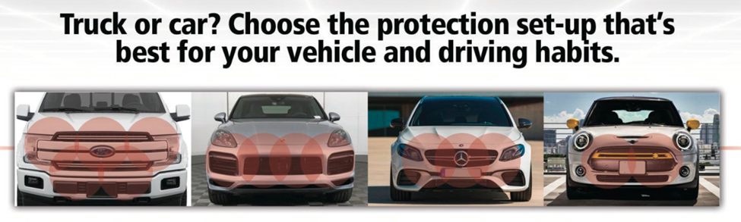

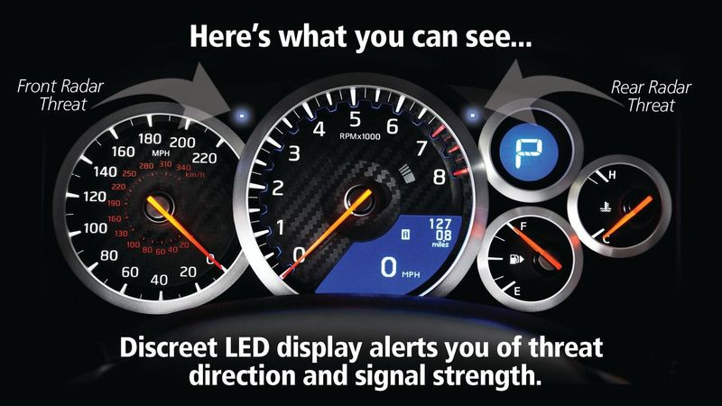

**S*pecial note:***

***If you have the ability to add a video clip to the K40 page, use the image and the link below.***



Click here: <https://www.dropbox.com/scl/fo/f425lk0fuh8vveaetyz8e/AKyf1-GBg7ZWWKGuCGrR__Q?e=1&preview=Car+Dealership+Image_FULL_HD.mp4&rlkey=xrcv2kzkmfh8hit47304igqlo&dl=0>

